CIRCLE

Circle was a book, published in London in 1937, as a survey of international constructive art. The joint editors, and organisers of the parallel ‘Exhibition of Constructive Art’, were the émigré Russian sculptor Naum Gabo (1890 – 1977), the British abstract artist Ben Nicholson and the modernist British architect, Leslie Martin. Gabo was one of several European artists and architects who came to England in the late 1930s to escape Nazi and Soviet oppression. In London, he became a friend of Ben Nicholson with whom he discussed starting an annual publication promoting the constructivist concept of a synthesis of modernist architecture and constructivist painting and sculpture. Circle was the outcome of these discussions, and the book and exhibition constituted the first comprehensive exposition of constructive art in Britain. Circle featured fifty-one participants including ten from Britain. But, while those from overseas included major international figures such as Mondrian, Léger, Gropius and Le Corbusier, the British artists – with the exception of Nicholson, Barbara Hepworth and Henry Moore – were far less well-known and the constructivist credentials of several were very weak. The intention to publish Circle annually was frustrated by the outbreak of Second World War and the departure of Gabo and others to the USA.

Naum Gabo was a leading Russian exponent of Constructivism who emigrated to England in 1936 after leaving Russia and then living for a time in Germany. In London, together with Mondrian, he became a neighbour and friend of Ben Nicholson and the constructivist artist, John Cecil Stephenson. From these contacts emerged the plan to launch an annual publication, Circle, as a survey of international constructive art covering painting, sculpture and architecture, and to hold related exhibitions. Gabo, Nicholson and the architect Leslie Martin co-edited the book which was published in 1937, alongside an exhibition of constructive art in the London Gallery.

The book’s editorial claimed that “a new cultural unity is slowly emerging out of the fundamental changes which are taking place in our present-day civilization” and that this unity was “the constructive trend in the art of our day”. To support these claims, the book showed 170 photographs of the work of twenty one painters, ten sculptors and twenty architectural practices. The exhibition was less comprehensive. Circle also carried a number of essays by artists and architects whose work was illustrated and also by the art critics Herbert Read and Sigfried Geidion, the modernist typographer, Jan Tschichold and the scientist J. D.Bernal. Read, who had earlier commented that Nicholson’s white reliefs were “the best type of painting to go with the new architecture”, wrote about the search for new forms of artistic expression and suggested that “there is no one way of doing this … we are at a stage of experimentation.” A wide range of ideas within Circle’s “constructive” sub-title were also evident from differences in the authors’ essays. For example, Mondrian, unlike Gabo, made no reference to constructivism in expounding his philosophy of neo-plasticism, while Bernal was concerned with art’s search for social utility and Nicholson suggested that “painting and religious experience are the same thing.” That said, the concept of the art work as being essentially rational and constructed from basic elements, underlay almost everything illustrated and written about in Circle.

The artists and architects illustrated in Circle included many major figures from across Europe, such as Arp, Gropius, Klee, Corbusier, Léger, Moholy Nagy, and Mondrian. It is also open to question as to whether some of the British artists, apart from John Cecil Stephenson (1889 – 1965), merited a constructivist label. Hepworth and Moore were making bio-morphic sculptures while the painters Arthur Jackson, John Piper and Winifred Dacre were experimenting with hard-edge abstraction. Nicholson, too, slowly abandoned a constructivist approach when he later became the dominant landscape- influenced abstractionist of the St Ives artists. Nevertheless, Circle has significance in being the first event in British art history in which a comprehensive array of international constructive art, including a British component, was presented to the British art world.

The organisers’ intention to make this an annual event collapsed when, in response to the worsening international situation in 1938 and the outbreak of war in 1939, the European émigrés began leaving Britain for the USA, and Nicholson left London to live in St. Ives.

References and further reading

Checkland S. J., (2000), Ben Nicholson: the Vicious Circle of his Life and Art,
London: John Murray.
Harrison C., (1981) English Art and Modernism 1900 – 1939, New Haven & London:
Yale University Press.
Martin J.L., Nicholson B., Gabo. N., eds. (1937) Circle, London: Faber & Faber
Nash A., Merket J., eds (1985) Naum Gabo: 60 Years of Constructivism, New York:
Prestel Verlag.
Read H., in Axis magazine April 1935, p. 16.

Images
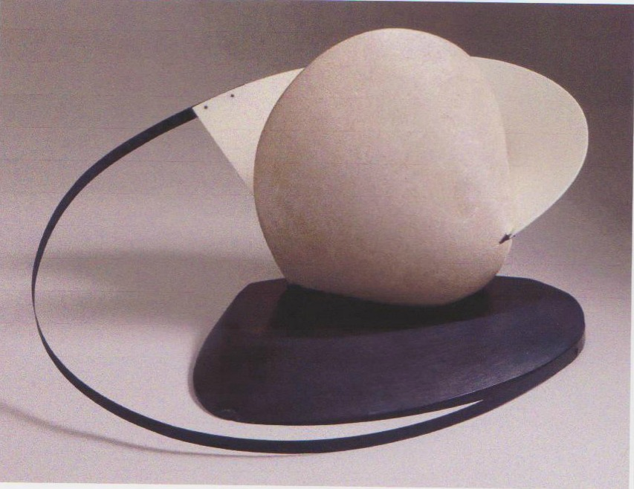
Naum Gabo, Stone with a Collar, 1936/7, limestone, brass, slate, 37 x 72 55 cms
www.tate.org.uk/art/artworks/gabo-construction-stone-with-a-collar/t06975

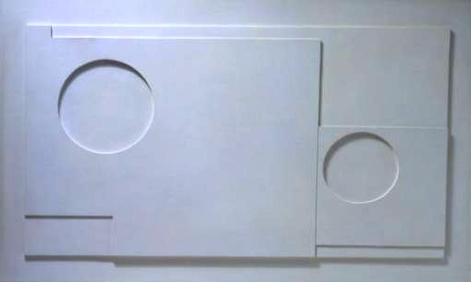
Ben Nicholson, White Relief, 1935, painted wood, 42.3 x 67.6 cms

www.mutualart.com/artwork/1935-white-relief/084F603C64BBD135

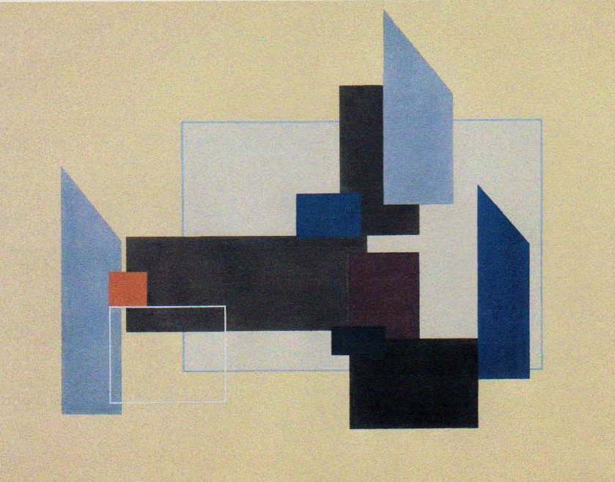
John Cecil Stephenson, Painting, 1937, tempera on canvas, 71.1 x 91.4 cms

www.tate.org.uk/art/artworks/stephenson-painting-t00617

